                                                     THE SENTINEL

**PROBLEM STATEMENT**

Sentiment Analysis of COVID-19 Tweets – Visualization Dashboard

**GENERAL DESCRIPTION**

**Twitter** has become a central site where people express their **opinions** and **views** on various issues going on in the country. Emerging events or news are often followed by almost **instantTwitter outburst**, providing a unique opportunity to gauge the relation between expressed public sentiment and any major national event. Consequently, **sentiment analysis** can help us explore how these events affect public opinion. While traditional content analysis takes days or weeks to complete since the Human Language is a very complexand **sophisticated** form of communication .Further, making a computer understand this language is a very difficult task especially when using traditional methods of programming and data structures. Our proposed model can analyse sentiment in the entire **Twitter traffic** about the decisions of the government and **deliverresultsinstantly** and **continuously**. For years now, **Artificial Intelligence** and **Machine Learning** has been an area of great interest among Computer Science Enthusiasts and this project focuses on one of at the very important components of ML which is **Natural Language Processing (NLP).**

Here we make use of the **Granger causality test** to first show**sentiment polarity (positive and negative sentiment)** expressed in the tweets of individuals. Our model then adapts the **Support Vector Machine classification mechanism** to categorize tweets into **three sentiment categories (positive, negative and neutral)**, resulting in improved predictive power of the classifier and the final results can be viewed on a **visualization dashboard through a pie chart**. Our proposed solution offers the public, the media, politicians and scholars a new and timely perspective on the dynamics of the public opinion.

**WORKING**

The first part of the project is a **sentiment analyser**. Built on the**Aylien API using Python**,  the  project  uses  **Machine  Learning** to  provide  a  **polarity**for  a  given  query which is of three types - **Positive, Negative and Neutral**. If the polarity of a query is negative, it is deemed unsuitable.

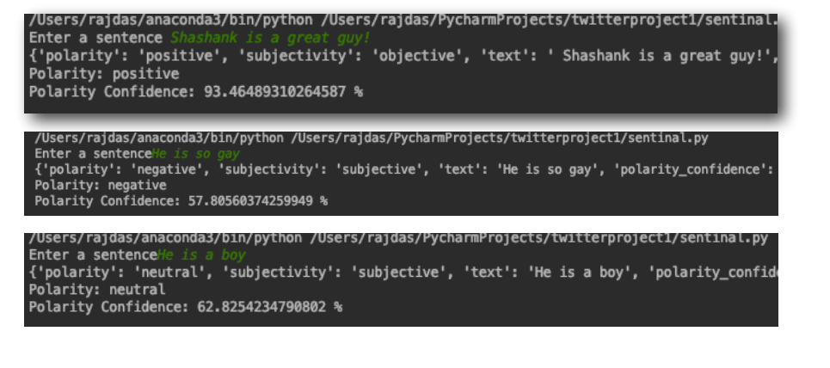

The  second  part  of  the  project  is  for  **Brand/Product Analysis** and  is  based  on  thepreviously  discussed  model.  Here,  instead  of  taking  queries  from  the  user,  it  takesdata  from  social  media  platforms  like **Twitter**,  analyses  them,  creates  **CSV  file** andthen provides a **pie chart of the sentiments** for the same.

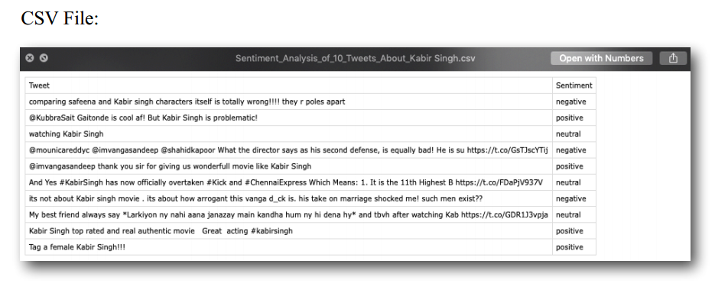

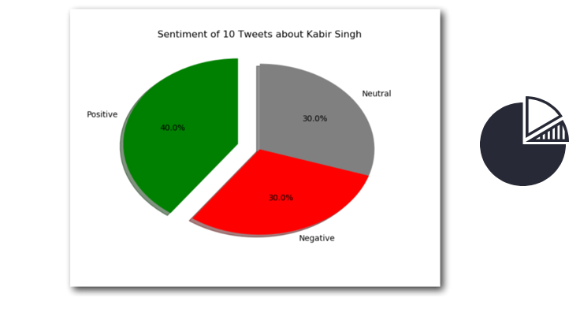

**NOVELTY**

* User Friendly
* Flexible and Easy to Correct
* Unbiased
* Easy to configure and setup
* Wide range of Applications
* Easy to import and use
* Interactive GUI
* Easy to Navigate
* Features are easily accessible

 This project focuses on solving three problems of the modern society namely,

1.  **Cyber Bullying**

2. **Brand/Product Analysis**

3.  **Categorize** opinions expressed in **feedback forums**.

 Our model can further **monitor hashtags** to know what subjects are being talked about the most and even conduct sentiment analysis of the hashtags to know public reaction on various decisions.

 A **pie chart** can be generated after the classification of tweets for visual aid in understanding the public sentiment.

**BUSINESS AND SOCIAL IMPACT**

* It can be **integrated on social media platforms** to prevent **cyber bullying, cybercrimes, depression and teenage suicides**.

* Companies can **predict customer reaction** on their certain product about to be launched

* Can be used to **classify consumer reaction** and predict the success or imminent sales of a certain product or entity being introduced into the market based on the buzz it is able to create on the internet.

**BUSINESS MODEL**

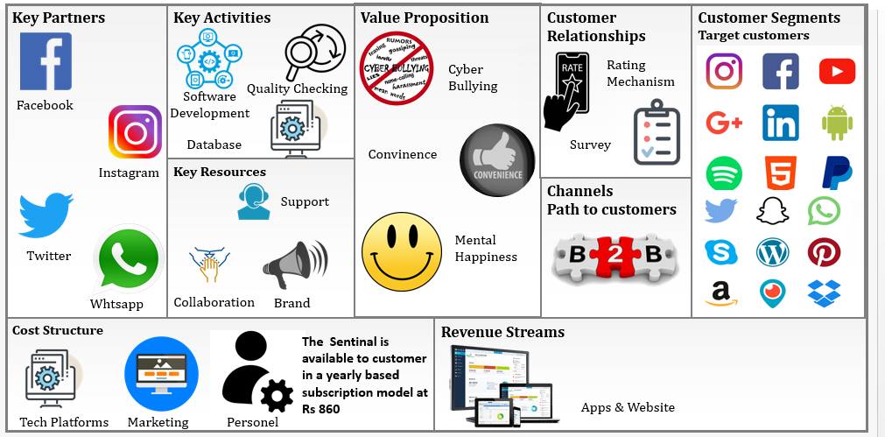

**TECHNOLOGY STACK**

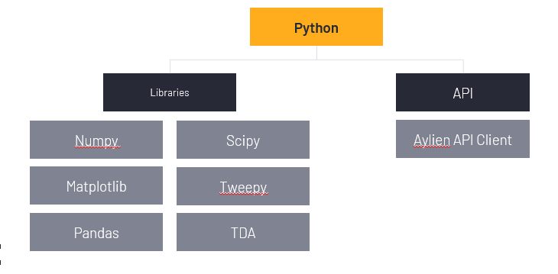

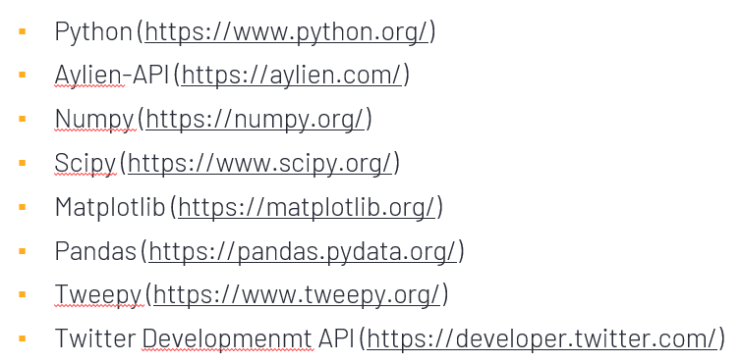

**SCOPE OF WORK**

**Timeline:**

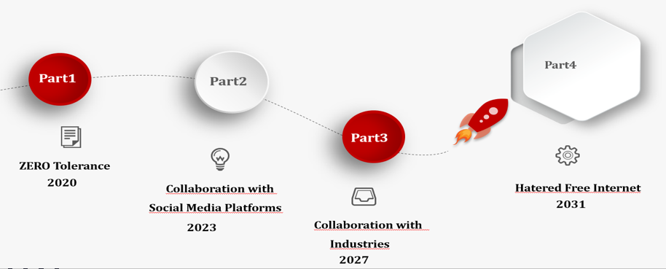

**Future Workplan:**

